**Project Documentation**

**FitFlex**: **Your Personal Fitness Companion**

1**. Introduction**

Project Title: FitFlex – Your Personal Fitness Companion

Team ID: NM2025TMID39961

Team Leader: Marcia Jennifer. S sac2427csc5593@ssacollegechennai.com Team members:

1.Mariya Rinolda. S sac2427csc5554@ssacollegechennai.com

2.Monisha. S sac2427csc9478@ssacollegechennai.com

3. Nandhini. S sac2427csc5464@ssacollegechennai.com

2. **Project Overview**

**Purpose**:

FitFlex helps users build healthy habits, track workouts, and stay motivated. It is not just a fitness tracker – it is like a friend that reminds, guides, and cheers you throughout your journey.

**Unique Features**:

* Daily mood check before workout suggestions
* Smart rest timer with calming sounds
* One-minute quick workouts for busy days
* Voice notes for logging meals instead of typing
* Personal cheer-up quotes after every workout
* Weekly “Wellness Challenge” with friends

3**. Architecture**

* Frontend: React.js (Web), React Native (Mobile)

* Backend: Node.js with Express.js

* Database: MongoDB (user progress, workouts, meals)

* Special Add-on: Push notifications for daily reminders

4**.Setup Instructions**

Requirements: Node.js, MongoDB, Git, Expo CLI

Steps:

git clone <repo-link> cd client && npm install cd ../server && npm install npm start

**5. Folder Structure**

wow-fitzz/ ├── public/

│ ├── favicon.ico

│ ├── index.html

│ ├── logo192.png

│ ├── logo512.png

│ ├── manifest.json

│ └── robots.txt

│

├── src/

│ ├── assets/ # images, icons, fonts

│ ├── components/ # Navbar, Footer, Hero, About, etc.

│ ├── pages/ # Home, Exercise, BodyPartsCategory, EquipmentCategory │ ├── styles/ # About.css, Navbar.css, Hero.css, etc.

│ │

│ ├── App.css

│ ├── App.js

│ ├── App.test.js

│ ├── index.css

│ ├── index.js

│ ├── logo.svg

│ ├── reportWebVitals.js

│ └── setupTests.js

│

├── .gitignore

├── package-lock.json

├── package.json

└── README.md

**6. Running the Application**

* Web App:

cd client npm start

* Mobile App:

cd mobile npx expo start

* Server:

cd server npm start

**7. API Endpoints**

* User
* POST /user/register → Register
* POST /user/login → Login

* Workout
* GET /workouts/today → Get today’s workout
* POST /workouts/log → Save workout

* Meals
* POST /meals/voice → Log meal with voice note
* GET /meals/history → See meal history

1. **Authentication**

* Simple email & password login

* OTP verification for extra safety

1. **User Interface**

* Home Dashboard – Today’s workout, meal, and motivation

* Workout Page – Videos, timers, and voice coach

* Meal Tracker – Voice or photo-based logging

* Progress Chart – Weekly and monthly stats

1. **Testing**

* Manual testing with Postman (API)

* Basic UI testing on mobile and web

1. **Screenshots or Demo**

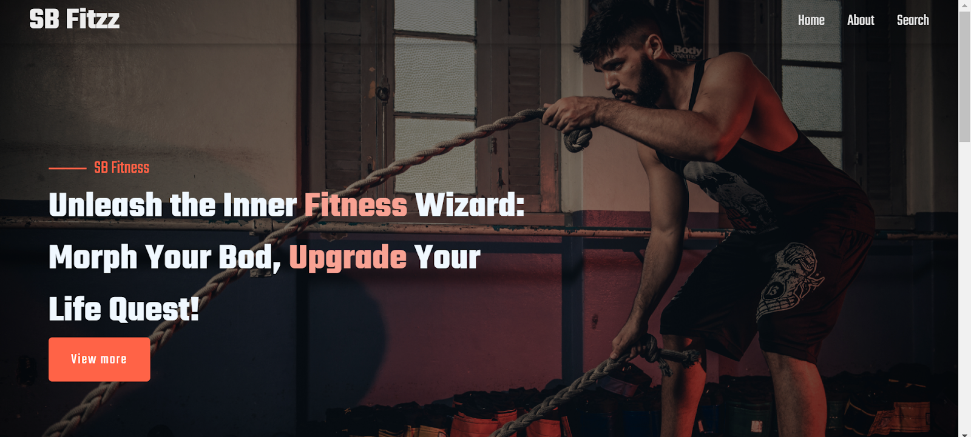

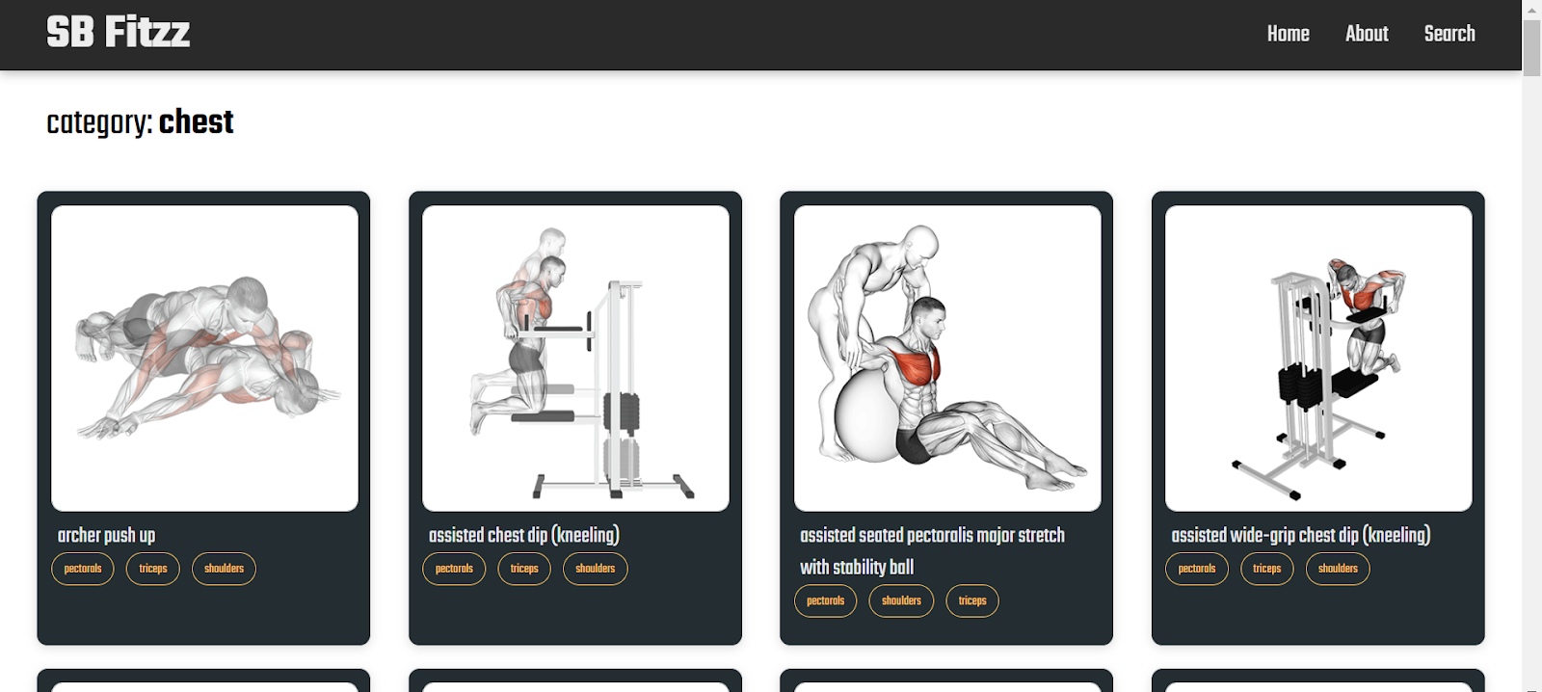

12.**Known Issues**

* Voice note meal logging may fail in noisy places

* Some workouts need internet for video playback

* Dark mode not yet supported

13.**Future Enhancements**

* Offline workout mode

* Smartwatch integration

* AI coach for real-time correction

* Sleep tracker with bedtime reminders